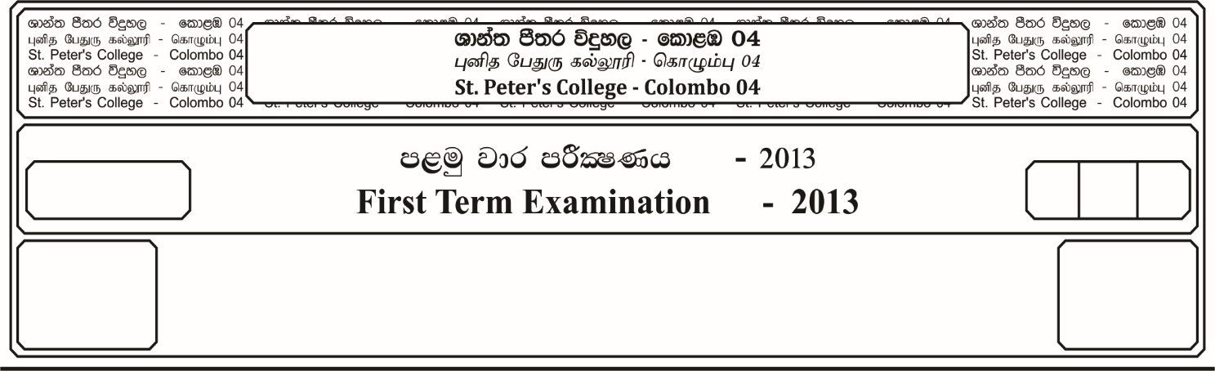

13 fY%aKsh

GRADE 13

E

$03$ meh

$03$ Hour

I

**m<uq jk jdr mÍCIKh - 2023**

**First Term Examination - 2023**

ixhqla; .Ks;h - ¸

**COMBINED MATHEMATICS – I**

10

* **Answer all the questions of Part A and any 05 questions of Part B.**

**Part -A**

01. Using the Principle of Mathematical Induction, Prove that,

**7 + 13 + 19 ……… + (6n + 1) = n(3n + 4)** for all **n z+**

02. **If *f* (*x*) = 1 -**  then find ***f* (*f* ())**

03. **If 3(2*x -1*) = 2*x* + 4** then solve for ***x***.

04. Find the turning points of the function ***f* (*x*) = 2*x*3 + 3*x*2 - 12*x* + 5**.

Hence, determine the range of ***x*** in which the function ***f* (*x*)** increases.

05. Let and $β$ be the roots of the equation ***x*2+ x – c = 0**, find the value of .

06. Show that  **= 1**

07. Sketch the graphs of ***y* = | 2*x* + 1|**  and ***y* = *x* +2**. Hence of otherwise solve the inequality.

**| 2*x* + 1 | *x* + 2**

08. Parametrical equations of a curve are given by ***x* = 5t2**  and **y = 3t + 1**. Show that the equation of the tangent at the point **(5, -2)** is **3*x* + 10y + 5 = 0**

09. Interate with respect to ***x***,

***dx***

10. Express **4 sin $θ$– 3 cos $θ$** in the form **R sin** **($θ-∝$)** , Where **R $>$ O** and **O $< ∝ {\overline{∧}}/2$**

Hence show that the greates value of $\frac{1}{4 Sin θ-3 Cos θ +7 }$ is $\frac{1}{2}$

**Part – B**

**Answer five (05) questions only.**

11. a). If and $β$ are the real distinct roots of the equation **(x - a $)^{2}$ + (x - b $)^{2}$ = 2**.

Prove that **| a - b| = 2**

Show also that, **(a $∝$ + b $β$) (b $∝$ + a $β$) = (a + b $)^{2}$**. Hence find the equation, whose roots are **( $∝$ + 2 $β$)** and **(2a + $β$)**.

b). When the function ***f* (*x*) = 2*x*4 + 3*x*3 + a*x*2 + b*x* + c** is divided by **(*x* - 2) (*x* + 3)**, the remainder is **-5*x* + 2**

Prove that **6*a* = - 64 - C = 6b**

Also find the remainder in terms of a, when ***f (x)*** is divided by ***(x - 1)***

12. a). Let ***f* (*x*) = $\frac{4 (2+ x^{2})}{2x+1}$** , ***x $∈$* R, x $≠$- $1/2$**

Show that ***f* (*x*)** cannot lie between **4** and **-8**

Find the values of x, for which

i. ***f* (*x*) = -8** ii. ***f* (*x*) = 4**

Hence draw the graph of ***f* (*x*)**

b). Find the range of values of x for which,

***x* - 4 < *x*2 - 4*x* < 5**

13. a). Show that the arithmetic mean of two positive numbers is greater than or equal to their geometric mean.

Hence show that, when a, b, c, d, are real positive numbers then,

**a4 + b4 + c4 + d4 4 abcd**

b). Given that $\log_{2}{x}$ **+ 2 $\log_{4}{y}$ = 4**, show that ***xy* = 16**

Hence solve for x and y the simultaneous equations,

= 1

+ 2 = 4

14. a). Give that **y = e2t cos 3t**  and $\log_{e}{x=\sin{3t}}$, where t is a parameter. Prove that.

i. $\frac{dy}{dx}$ **= $\left(\frac{2}{3} -\tan{3t}\right)$. $e^{(2t – sin3t)}$**

ii. If $\frac{dy}{dx}$ **= 0** then ***x* = $e^{3/{\sqrt{13}}}$ or *x* = $e^{{-2}/{\sqrt{13}}}$**

b). If **y = xn**  Where n is a constant then show that,

$x^{2}$ $\frac{d^{2} y}{{dx}^{2}}$**-** **(2n -1) *x $\frac{dy}{dx}$*  + $n^{2} y$ = 0**

c). A ladder 10m long is leaning against a wall. The bottom of the ladder is pulled along the ground away from the wall at the rate of **1.5 m/sec.** Show that its height on the wall decreasing, when foot of the ladder is 6 meters away form the wall is  **m/sec.**

15. a). Using partial fractions. Show that,

$\int{\frac{1}{x^{2} - a^{2}}}$**d*x* = $\frac{1}{2a}$ $ln$ $\frac{(x-a)}{(x+a)}$ + c**

b). Using the method of integration by parts, find,

$\int{xe^{-x}} dx$.

c). Using the substitution ***x* = 2 sin2 + 3** for **O** .

Prove that, **dx = – 1**

16. Two sides of a parallelogram are given by equations **x – y – 2 = 0** and **x – 4y + 4 = 0**.

The diagonals of the parallelogram intersect at the origin. Find,

i. The equations of the remaining sides of the parallelogram.

ii. The equations of the diagonals.

iii. Show that the area of the parallelogram is $\frac{32}{3}$ square units.

17. a). Show that **(Cos *x* + Cos *y $)^{2}$* + (Sin *x* + Sin *y* = 4 cos2 ()**

Hence or otherwise show that **cos1 $5^{o}$ = $\frac{\sqrt{2} + \sqrt{6}}{4}$**

b). Prove that,

**tan 7 $0^{o}$– tan 2 $0^{o}$– 2 tan 4 $0^{o}$ = 4 tan 1 $0^{o}$**

c). State the sine rule for a triangle ABC. Prove in the usual notation for a triagle ABC that,

$\frac{a^{2}-b^{2}}{c^{2}}$**= $\frac{Sin (A-B)}{Sin ( A+B)}$**

d). Solve for ***x***,

**ta $n^{-1}$ 2*x*  + ta $n^{-1}$ 3*x* = $\frac{\overline{∧}}{4}$, x >O**